**Automated Detection of Diabetic**

**Retinopathy**

Anita Mohandas mohandas.a@husky.neu.edu

Radhika Shroff Shroff.r@husky.neu.edu

Sindhuri Yamala yamala.s@husky.neu.edu

*Information System, Northeastern University*

**Abstract:**

Diabetes is a chronic end organ disease that occurs

when the pancreas does not secrete enough insulin or the

body is unable to process it properly. Over time, diabetes

affects the circulatory system, including that of the retina.

Diabetic retinopathy is a medical condition where the retina

is damaged because fluid leaks from blood vessels into the

retina. Ophthalmologists recognize diabetic retinopathy

based on features, such as blood vessel area, exudes,

hemorrhages, microaneurysms and texture. In this paper we

review algorithms used for the extraction of these features

from digital fundus images. Furthermore, we discuss

systems that use these features to classify individual fundus

images. The classifications efficiency of different DR

systems is discussed. Most of the reported systems are

highly optimized with respect to the analyzed fundus images,

therefore, a generalization of individual results is difficult.

However, this review shows that the classification results

improved has improved recently, and it is getting closer to

the classification capabilities of human ophthalmologists.

**Keywords**

Diabetic retinopathy, Fundus images, Automated detection,

Blood vessel area, Exudes, Hemorrhages, Microaneurysms

Maculopathy.

**Introduction:**

The fast progression of diabetes is one of the main

challenges of current health care. The number of people

afflicted with the disease continues to grow at an alarming

rate. The World Health Organization expects the number of

people with diabetics to increase from 130 million to 350

million over the next 25 years. The situation is made

worse by the fact that only one half of the patients are

aware of the disease. And in the medical perspective,

diabetes leads to severe late complications. These compli-

cations include macro and micro vascular changes which

result in heart disease, renal problems and retinopathy. For

example, studies in the United States show that diabetes is

the fifth-deadliest disease, and still there is no cure. In the

United States, the total annual economic cost of diabetes in

2002 was estimated to be $132 billion, this translates to one

out of every 10 health care dollars spent.

Diabetic retinopathy (DR) is a common complication of

diabetes. Indeed, it is so common that it is the leading cause

of blindness in the working population of western countries

The rate of diabetes is increasing, not only in developed

countries, but in underdeveloped countries as well.

Unfortunately, most developing countries lack basic recoding of DR cases. It is estimated that 75% of people with diabetic etinopathy live in developing countries.

Regardless of the health care situation

in their country of origin, people with diabetes are 25 times

more likely to develop blindness when compared with

individuals who do not suffer from this disease. DR is

a silent disease, because it may only be recognized by the

patient when the changes in the retina have progressed to a

level where treatment is complicated and nearly impossible.

The prevalence of retinopathy varies with the age of onset of

diabetes and the duration of the disease.

So far, the most effective treatment for DR can be

administered only in the first stages of the disease.

Therefore, early detection through regular screening is of

paramount importance. To lower the cost of such

screenings, digital image capturing technology must be used,

because this technology enables us to employ state-of-the-

art image processing techniques which automate the

detection of abnormalities in retinal images.

**Causes:**

The recent increase in diabetes can be attributed to an aging

population and increasing prevalence of obesity as well as

sedentary life habits. Genetic inheritance plays a role in

both, type 1 and type 2 diabetes. But it appears that type 1

diabetes is also triggered by some (mainly viral) infections.

There is also a genetic element in individual susceptibility

to some of these triggers which has been traced to particular

human leukocyte antigen genotypes. However, even in

those who have inherited the susceptibility, type 1 DM

seems to require an environmental trigger. Some evidence

indicates that the B4 virus might be such a trigger.

**Effects:**

Diabetes affects the kidney, eyes, nerves and heart. In the

following sections, we have discussed these affects briefly

**Diabetic Retinopathy**

Diabetes mellitus often results in diabetic retinopathy which

is caused by pathological changes of the blood vessels

which nourish the retina. DR is the main cause of new cases

of blindness among adults aged 20-74 years. During the

first 20 years of the disease, nearly all patients with type 1

diabetes and >60% of patients with type 2 diabetes have

retinopathy. In the Wisconsin Epidemiologic Study of DR,

3.6% of younger-onset patients (type 1 diabetes) and 1.6%

of older-onset patients (type 2 diabetes) were legally blind

In the younger-onset group, 86% of blindness was

attributable to DR. In the older-onset group, in which other

eye diseases were common, one-third of the cases of legal

blindness was due to DR. Figure 1 shows the different

features of the typical DR image.

DR occurs when the increased glucose level in the

blood damages the capillaries, which nourish the retina.

Because of this damage, the capillaries leak blood

and fluid on the retina. The visual effects of this

leakage are features, such as microaneurysms, hemor-

rhages, hard exudates, cotton wool spots or venous loops,

of DR [6,84].

***Types of diabetic retinopathy***

DR can be broadly classified as no proliferative DR (NPDR) and proliferative

DR (PDR). Depending on the presence of specific DR

features, the stages can be identified [6,17]. The

following list describes three subclasses of NPDR as well

as PDR

* **Mild NPDR:** at least one microaneurysm with orwithout the presence of retinal haemorrhages, hardexudates, cotton wool spots or venous loops (Fig.2(b)). Approximately 40% of people with diabetes have at least mild signs of diabetic retinopathy.
* **Moderate NPDR:** numerous microaneurysms and retinal haemorrhages are present. A limited amount and cotton wool spots of venous beading can also be seen (Fig.2(c)). 16% of the patients with moderate NPDR will develop PDR within 1 year.
* **Severe NPDR**: is characterized by any one of the following (4-2-1 rule) characteristics: (1) numerous haemorrhages and microaneurysms in 4 quadrants of the retina (2) venous beading in 2 or more quadrants (3) Intraretinal microvascular abnormalities in at least 1 quadrant (Fig. 2(d)). Severe NPDR carries a 50% chance of progression to PDR within 1 year.
* **PDR:** is the advanced stage; signals, sent by the retina for nourishment, trigger the growth of new blood vessels. These blood vessels do not cause symptoms or vision loss.But, their walls are thin and fragile, this leads to a high risk that they leak blood (Fig. 2(e)). This leaked blood contaminates the vitreous gel and this causes severe vision loss and even blindness. About 3% of people, with this condition, may experience severe visual loss.

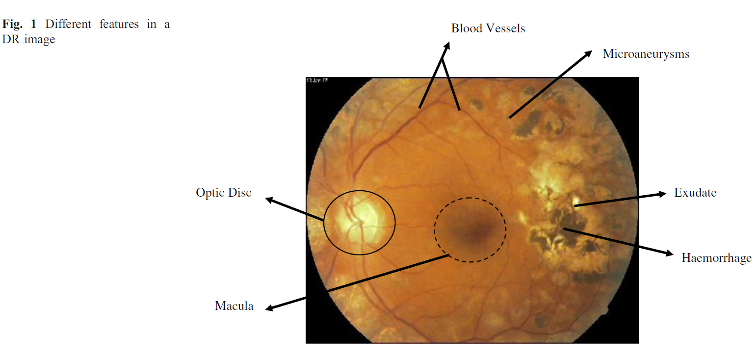

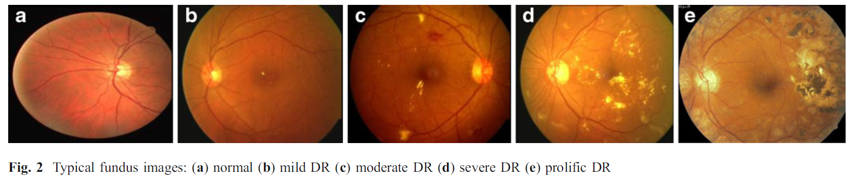

Laser photocoagulation cauterizes ocular blood vessels,

which effectively stops their leakage. The focal laser

treatment method reduces retinal thickening. This may

prevent worsening of retinal swelling. To be specific, this

treatment reduces the risk of vision loss by 50%. For a

small number of cases, with total vision loss, improvement

is possible.

**Fundus images**

Medical image analysis is a research area that currently

attracts lots of interest from both scientists and physicians.

The objective of this field is to develop computational tools

which will assist quantification and visualization of

interesting pathology and anatomical structures. These tools

work with digital fundus images of the eye. The procedure

of taking fundus images starts by dilating the pupil with

pharmaceutical eye drops. After that the patient is asked to

stare at a fixation device in order to steady the eyes. While

taking the pictures, the patient will see a series of bright

flashes. The entire process takes about five to ten minutes.

To ensure that DR treatment is received on time, the eye

fundus images of diabetic patients must be examined at

least once a year.

**Feature extraction methods and analysis**

Image processing can do both reduce the workload of

screeners and play a central role in quality assurance tasks.

Therefore, there has been an increase in the application of

digital image processing techniques for automatic detection

of DR [63]. For example, color features on Bayesian

statistical classifier was used to classify each pixel into

lesion or non-lesion classes [73].

The following sections describe blood vessels, exudes,

hemorrhages, microaneurysms and maculopathy detection

techniques. These detection techniques yield most of the

features which are used in automated DR detection systems.

**Microaneurysms detection**

Microaneurysms detection is very important, because these

structures constitute the earliest recognizable feature of DR.

The first reports which link these structures to DR date

back to 1879 [11]. More recently, Jalli et al. have analyzed

the appearance and disappearance of microaneurysms in

different phases of fluorescein angiography [34]. In a

similar study both formation rate and disappearance of

microaneurysms in early DR were analyzed [30]. The

microaneurysms turnover were computed reliabibly from

color fundus images [9]. They used a new method called

MA-tracker to count microaneurysms. They showed that

the microaneurysms remain stable over time, but only 29%

remain at the same place.

Figure 5 shows the results of microaneurysms detection

for normal and PDR [4]. In example the green component,

of the RGB fundus image, was chosen to obtain the

microaneurysms. Similar to the exudates detection algorithm,

first the prominent structures within retina images,

such as blood vessel tree and optic disc are to be removed.

After that a sophisticated sequence of image processing

algorithms was used to determine the areas within the

fundus images to get microaneurysms

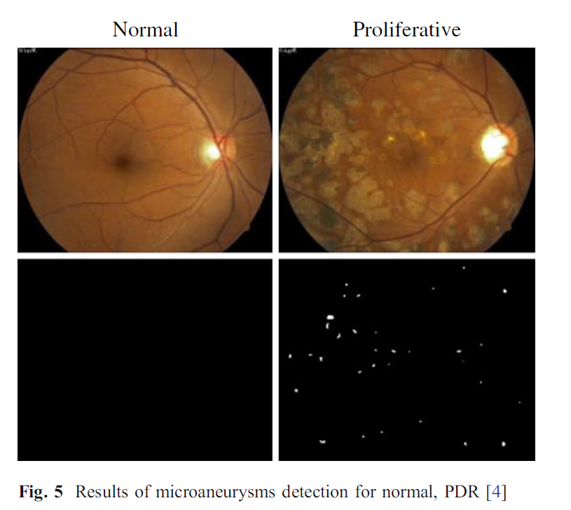

**Classification methods**

Color features were used on Bayesian statistical classifier

classify each pixel into lesion or non-lesion classes [73].

They have achieved 100% accuracy in identifying all the

retinal images with exudates, and 70% accuracy in

classifying normal retinal images as normal.

DR and normal retina were classified automatically

using image processing and multilayer perceptron neural

network The system yielded a sensitivity of 80.21%

and a specificity of 70.66%. Automated diagnosis of

NPDR, based on three lesions: hemorrhages and microaneurysms

hard exudates, and cotton wool spots, was

studied. The method could identify the NPDR

stage correctly with an accuracy of 81.7%.

Exudates, haemorrhages, and microaneurysms were used

for screening of DR subjects. The sensitivity and

specificity of their software was 74.8% and 82.7%,

respectively in differentiating DR and normal subjects

correctly.

Early detection of DR (presence of microaneurysms)

was proposed based on decision support system by Kahai et

al. Bayes optimality criteria was used to detect

microaneurysms. Their method could identify the

early stage of DR with a sensitivity of 100% and specificity

of 67%.

Normal, mild, moderate, severe and prolific DR stages

were automatically classified using both area and perimeter

of the RGB components of the blood vessels together with

a feedforward neural network. System average

classification efficiency was 84% and sensitivity, specificity

were 90% and 100% respectively. Nayak et al. have used

exudates and blood vessel area along with texture parameters

coupled with neural network to classify fundus images

into normal, NPDR and PDR.

They obtained a detection accuracy of 93%, sensitivity and specificity of 90% and 100% respectively. Recently, bispectral invariant features were used as features for the support vector

machine classifier to classify the fundus image in to

normal, mild, moderate, severe and prolific DR classes by

Acharya et al. They have demonstrated an average

accuracy of 82% and sensitivity, specificity of 82% and

88% respectively. Normal, mild, moderate, severe and

prolific classes of DR were classified automatically based

on haemorrhages, microaneurysms, exudates and blood

vessel areas with a support vector machine classifier.

The system was able to identify the unknown class

accurately with an efficiency of more than 85% and a

sensitivity of more than 82% and a specificity of 86%.

Nicolai et al. have designed an automated lesion system,

which identified 90.1% of patients with DR and 81.3% of

patients without DR, when applied in a screening population

comprising of patients with untreated DR. The

automated system demonstrated a sensitivity of 93.1% and

a specificity of 71.6%.

Usher et al. have designed a support system for DR

screenings. Their system showed a maximum sensitivity

for the detection of any retinopathy on a per patient

basis of 95.1%, accompanied by a specificity of 46.3%. The

specificity could be increased as far as 78.9%, but this

increase was accompanied by a fall in sensitivity to 70.8%.

At a setting with 94.8% sensitivity and 52.8% specificity,

no cases of sight threatening retinopathy were missed.

Neubauer et al. have investigated both photography and

optic disc topography mode of the retinal thickness

**PROPOSED METHODOLOGY**

In recent years, most of the image processing researchers

indulged in the development of machine learning especially

deep learning approaches in the field of Hand-written digit

recognition such as MNIST dataset, image classification by

IMAGENET. Our proposed methodology strongly emerged

based on these key aspects of diseases severity classification

from the fundus images.

In general, especially classification of diseases with the

proposed architecture a DCNN[add citation] following these

basic steps to achieve maximum accuracy from the images

dataset are i) Data Augmentation ii) Pre-processing iii)

Initialization of Networks iv) training v) Activation function

selections vi) Regularizations vii) Ensemble the multiple

methods.

In our proposed diabetic retinopathy classification model

in Fig.3.1, an architecture are condensed and its building

blocks are :

a. Data augmentation

b. Preprocessing

c. Deep Convolutional Neural Network Classification

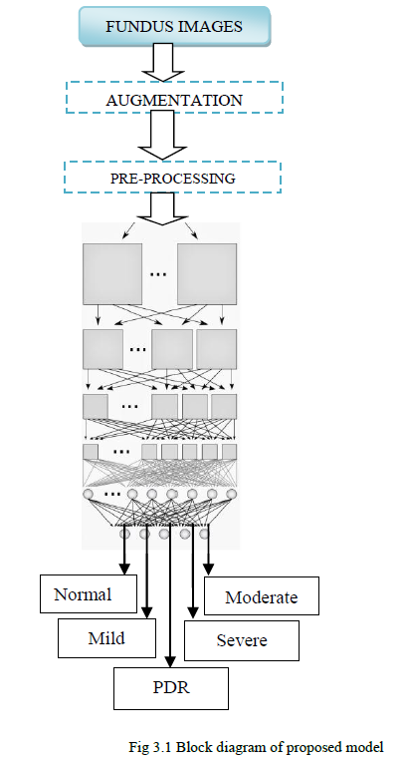

***A. DATA AUGMENTATION***

The fundus images are obtained from the different

datasets are taken under different camera with varying field

of view, non-clarity, blurring, contrast and sizes of images

different. In data augmentation, contrast adjustment, flipping

images, brightness adjustments are made.

***B. PREPROCESSING***

For Deep convolutional neural network worked on spatial

data of the fundus images. A primary steps involved in the

preprocessing is resizing the images. Before feeding into the

architecture for classification, convert the images in to gray

scale. And then, convert in to the L model. It is a

monochrome images which is used to highlights the

microaneurysms, and vessels in the fundus images. And

flatten the images in single dimensional for processing

further.

***C. CNN CLASSIFICATION***

In Image recognition, a Convolutional Neural

Network(CNN) is a type of feed-forward artificial neural

network in which the connectivity pattern between its

neurons is inspired by the organization of animal visual

cortex, whose individual neurons are arranged in such a way

that respond to overlapping regions tiling the visual field.

In deep learning, [10][11] the convolutional neural

network uses a complex architecture composed of stacked

layers in which is particularly well-adapted to classify the

images. For multi-class classification, this architecture

robust and sensitive to each feature present in the images.

Common layers deployed in making Deep

Convolutional Neural Network architecture(DCNN) are

shown in Fig. 3.2

i) Convolutional Layer

ii) Pooling Layer

iii) ReLU Layer

iv) Dropout layer

v) Fully connected Layer

vi) Classification Layer

**i) CONVOLUTIONAL LAYER :**

This is the first and foremost layer laid after the input

image which want to be classified. The backbone of the

convolutional neural network are : local receptive fields,

shared weights. These are making deep convolutional neural

network for image recognition.

Local receptive field :

During image recognition, convolutional neural network

consists of multiple layers of small neuron collections which

look at small portions of the input image.

Shared weights and bias :

Each feature map of the convolutional neural network

shared the same weights and bias values. This shared values

will represent the same feature all over the image. Depends on

the application, the feature map generation is varied.



The convolutional layer consists of kernel or set of filters (local receptive field). Each filter is convolved against the input image and extract the features by forming a new layer or activation map. Each activation map contain or represent some significant characteristic or features of the input image. In convolutional layer , NxN input neuron layer is convoluted with mxm filter. Then, the convolutional layer

output will be of size (N-m+1)x(N-m+1).It applied nonlinearity through neural activation function.

**ii)**

**POOLING LAYER :**

This is one of the most significant layer which helps the

network from avoiding over-fitting by reduce the parameters

and computation in the network.

It works as a form of non-linear down sampling. Pooling

partition the activation maps into set of rectangles

and collect

the maximum value in the sub region. It’s merely a downsize

the pixels with features. For instance, if NxN

input layer, that

will give output layer of N/K x N/K

layer.



The main significance of this layer is to ask whether a given feature is found anywhere in a region of the image. It then throws away the exact positional information.

***iii)***

***ReLU LAYER***

*:*

Rectified Linear Unit(ReLU) layer is an activation

function.

x –input to the neuron; also a ramp function

A smooth approximation to the rectifier is the analytic

Function.

This activation function induces the sparsity in the

hidden units. Also, It has been shown that the deep neural

networks can be trained efficiently compared than sigmoid

and logistic regression activation function.

***iv)***

***DROPOUT LAYER***

The crucial part of the deep convolutional neural network

is handling the parameters generated from each stacked layers

abundantly. It may cause over-fitting. For avoiding such

scenarios, droping out some neurons in the layer which

cascaded to the next layer. Usage of dropout mainly near

Fully connected layer to avoid excessive generation of parameters.

It is a widely used regularization techniques.

The feed forward operation of the dropout layer network[9]

can be described as (for *n*

ϵ {0,1,……. *N*-1} and any hidden

*rj(n)~ Bernoulli(p)*

*yd= r(n)* y(n)*

*zi(n+1)= wi(n+1)ydn+ bi(n+1);*

Where,

*rj(n) –Bernoulli random variables each of which has the*

*probability p of being 1;*

*ydn–dropout outputs from the layer n*

*wi(n) –Weights at layer n*

*bi(n)–bias at layer n of i hidden unit*

*f(zi(n)) –Activation function of n layer*

Also, it cause some drawbacks of missing out the

information from previous layers to the next layers. It shown

those effects on model learning the parameters through back

propagation error analysis.

***v)***

***FULLY CONNECTED LAYER :***

The layer which comes after the cascaded convolutional

and max/average pooling layer is called Fully connected layer. The high-level reasoning is done through this layer during classification.

A fully connected layer takes all neurons in the

previous layer from max-pooling layer and connects it to

every neuron it has. Fully connected layers are not spatially

connected anymore. It visualizes as one-dimensional layer.

***vi) CLASSIFICATION LAYER :***

After the stacked or deep multiple layers, the final layer is

a softmax layer which stacked at the end for classifying the

fundus image followed by the Fully connected layer output.

Here, the deciding as a single-class classification or multiclass

classification.

***Dataset :***

Kaggle dataset[19] : A high-resolution retina images taken

under a variety of imaging conditions. A clinician rated the

presense of diabetic retinopathy and scale it as 0-4. It contain

35126 training images and 53576 test images.

DRIVE dataset[20] : This database contain 40 color eye

fundus images taken with Canon CR5 3CCD camera with 45

degree field of view. It separated as train and test images by

two experts.

STARE[21] : This dataset contain 20 color eye fundus images

taken with the TopCon TRV camera with 35 degree filed of

view.Each imgae has a resolution of 700*605.

***RESULTS* :**

**5.1) Pre-processing :**

Input images is scaled down to 256x256. Fig.5.1, shows the

database input images and its resized monochrome images.

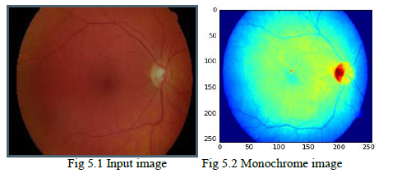

**Dataset (2):**

**Data Set Information:**

This dataset contains features extracted from the Messidor image set to predict whether an image contains signs of diabetic retinopathy or not. All features represent either a detected lesion, a descriptive feature of a anatomical part or an image-level descriptor.

**Attribute Information:**

1)The binary result of pre-screening, where 1 indicates severe retinal abnormality and 0 its lack.

(2-7) The results of MA detection. Each feature value stand for the  number of MAs found at the confidence levels alpha = 0.5, . . . , 1, respectively. (8-15) contain the same information as 2-7) for exudates. However, as exudates are represented by a set of points rather than the number of  pixels constructing the lesions, these features are normalized by dividing the   
number of lesions with the diameter of the ROI to compensate different image sizes.

16) The Euclidean distance of the center of the macula and the center of the optic disc to provide important information  regarding the patients condition.

17) The diameter of the optic disc.

18) The binary result of the AM/FM-based classification.

19) Class label. 1 = contains signs of DR (Accumulative label for the Messidor classes 1, 2, 3), 0 = no signs of DR.

**Logistic Regression:**

To predict an outcome variable that is categorical from predictor variables that are continuous and/or categorical

Logistic regression deals with this problem by using a logarithmic transformation on the outcome variable which allow us to model a nonlinear association in a linear way.

It expresses the linear regression equation in logarithmic terms (called the logit). It helps to determine:

relative importance of each predictor. Are there interactions among predictors How good is the model at classifying cases for which the outcome is known.

[Logistic regression](http://www.statisticssolutions.com/academic-solutions/membership-resources/member-profile/data-analysis-plan-templates/data-analysis-plan-logistic-regression/) is the appropriate regression analysis to conduct when the dependent variable is dichotomous (binary).  Like all regression analyses, the logistic regression is a predictive analysis.  Logistic regression is used to describe data and to explain the relationship between one dependent binary variable and one or more metric (interval or ratio scale) independent variables.

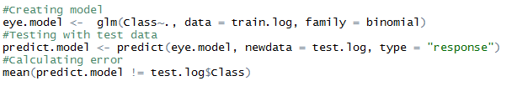

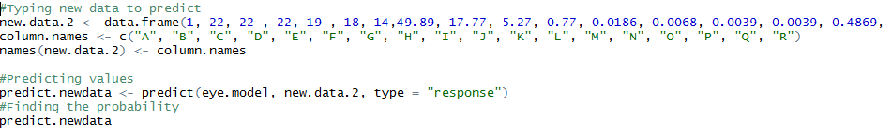



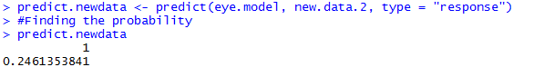

**Neural Network**

Neural networks (also referred to as [connectionist](https://en.wikipedia.org/wiki/Connectionism) systems) are a computational approach which is based on a large collection of neural units loosely modeling the way a biological [brain](https://en.wikipedia.org/wiki/Brain) solves problems with large clusters of biological neurons connected by axons. Each neural unit is connected with many others, and links can be enforcing or inhibitory in their effect on the activation state of connected neural units. Each individual neural unit may have a summation function which combines the values of all its inputs together. There may be a threshold function or limiting function on each connection and on the unit itself such that it must surpass it before it can propagate to other neurons. These systems are self-learning and trained rather than explicitly programmed and excel in areas where the solution or feature detection is difficult to express in a traditional computer program.

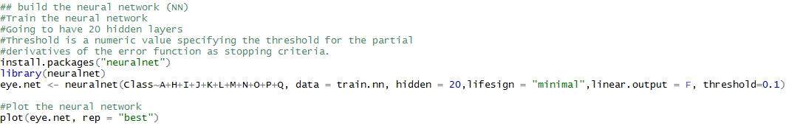

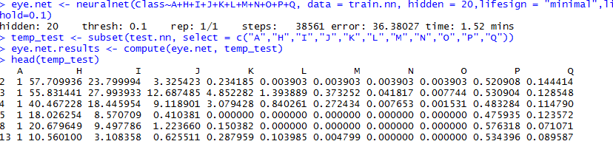

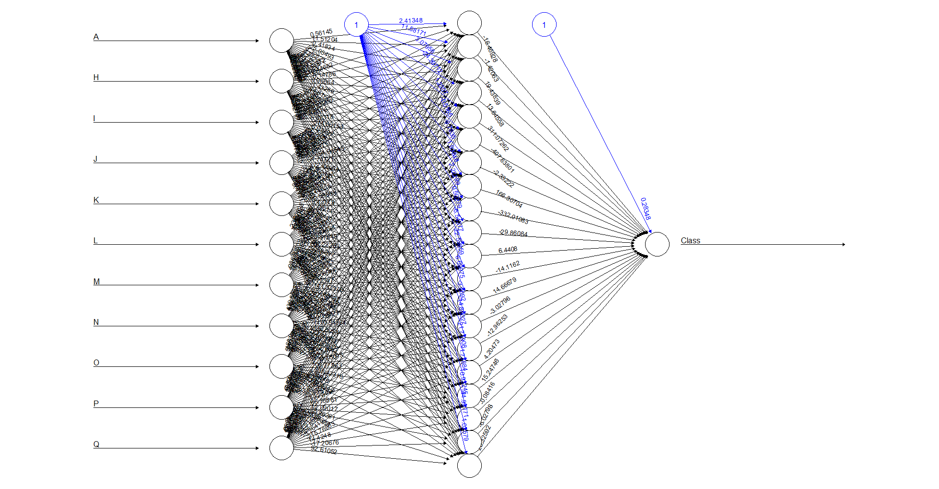

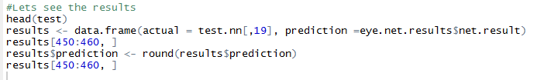

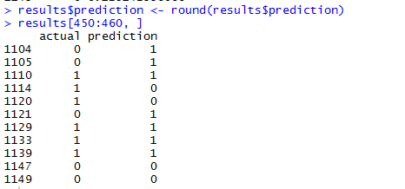

**Classification Tree (CART):**

Classification tree methods yield rectangular sets Aj by recursively partitioning the data set one X variable at a time. This makes the sets easier to interpret. For example, Figure 1 gives an example wherein there are three classes and two X variables. The left panel plots the data points and partitions and the right panel shows the corresponding decision tree structure. A key advantage of the tree structure is its applicability to any number of variables, whereas the plot on its left is limited to at most two. The first published classification tree algorithm is THAID.3,4 Employing a measure of node impurity based on the distribution of the observed Y values in the node, THAID splits a node by exhaustively searching over all X and S for the split {X ∈ S} that minimizes the total impurity of its two child nodes

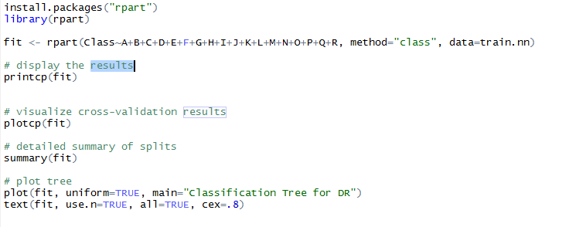

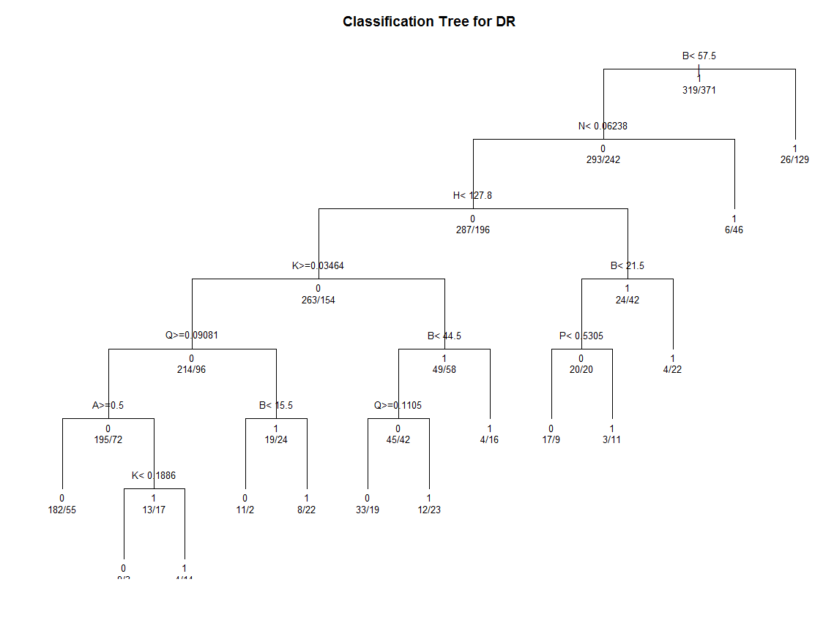





**KNN**

K nearest neighbors is a simple algorithm that stores all available cases and classifies new cases based on a similarity measure (e.g., distance functions). KNN has been used in statistical estimation and pattern recognition already in the beginning of 1970’s as a non-parametric technique.

KNN can be used for both classification and regression predictive problems. However, it is more widely used in classification problems in the industry. To evaluate any technique we generally look at 3 important aspects:

1. Ease to interpret output

2. Calculation time

3. Predictive Power

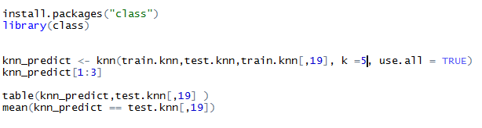



**CONCLUSION**

Among other existing supervising algorithms, most of them

are requiring more pre-processing or post-processing stages

for identifying the different stages of the diabetic retinopathy.

Also, other algorithms mandatorily requiring manual feature

extraction stages to classify the fundus images. In our

proposed solution, Deep convolutional Neural

Network(DCNN) is a wholesome approach to all level of

diabetic retinopathy stages. No manual feature extraction

stages are needed. Our network architecture with dropout

techniques yielded significant classification accuracy . True

positive rate(or recall) are also improved. This architecture

has some setbacks are: An additional stage augmentation are

needed for the images taken from different camera with

different field of view. Also, our network architecture is

complex and computation-intensive requiring high-level

graphics processing unit to process the high resolution images when the level of layers stacked more.

References:

<https://www.dropbox.com/home/INFO7390.16.FA.DataGeeks/Project?preview=Diabetic_retinopathy.pdf>

<http://www.saedsayad.com/k_nearest_neighbors.html>

<https://www.kaggle.com/c/diabetic-retinopathy-detection/forums/t/12853/literature-on-automatic-diabetic-retinopathy-detection>

<https://www.researchgate.net/post/Which_algorithm_can_be_used_for_detecting_Diabetic_Retinopathy_using_image_processing_algorithms>

<http://jamanetwork.com/journals/jamaophthalmology/fullarticle/1668203>

<http://www.umiacs.umd.edu/~ajain/ResearchPapers/DR_cvpr2009.pdf>

<http://ieeexplore.ieee.org/document/7018362/>

<https://en.wikipedia.org/wiki/Diabetic_retinopathy>

[https://archive.ics.uci.edu/ml/datasets/Diabetic+Retinopathy+Debrecen+Data+Set#](https://archive.ics.uci.edu/ml/datasets/Diabetic+Retinopathy+Debrecen+Data+Set)

<https://www.kaggle.com/c/diabetic-retinopathy-detection/data>

<https://www.r-bloggers.com/using-neural-networks-for-credit-scoring-a-simple-example/>

<https://www.kaggle.com/c/diabetic-retinopathy-detection>